Helping Without Hurting - Part 2_ Seeing God at Work - LifeChurch

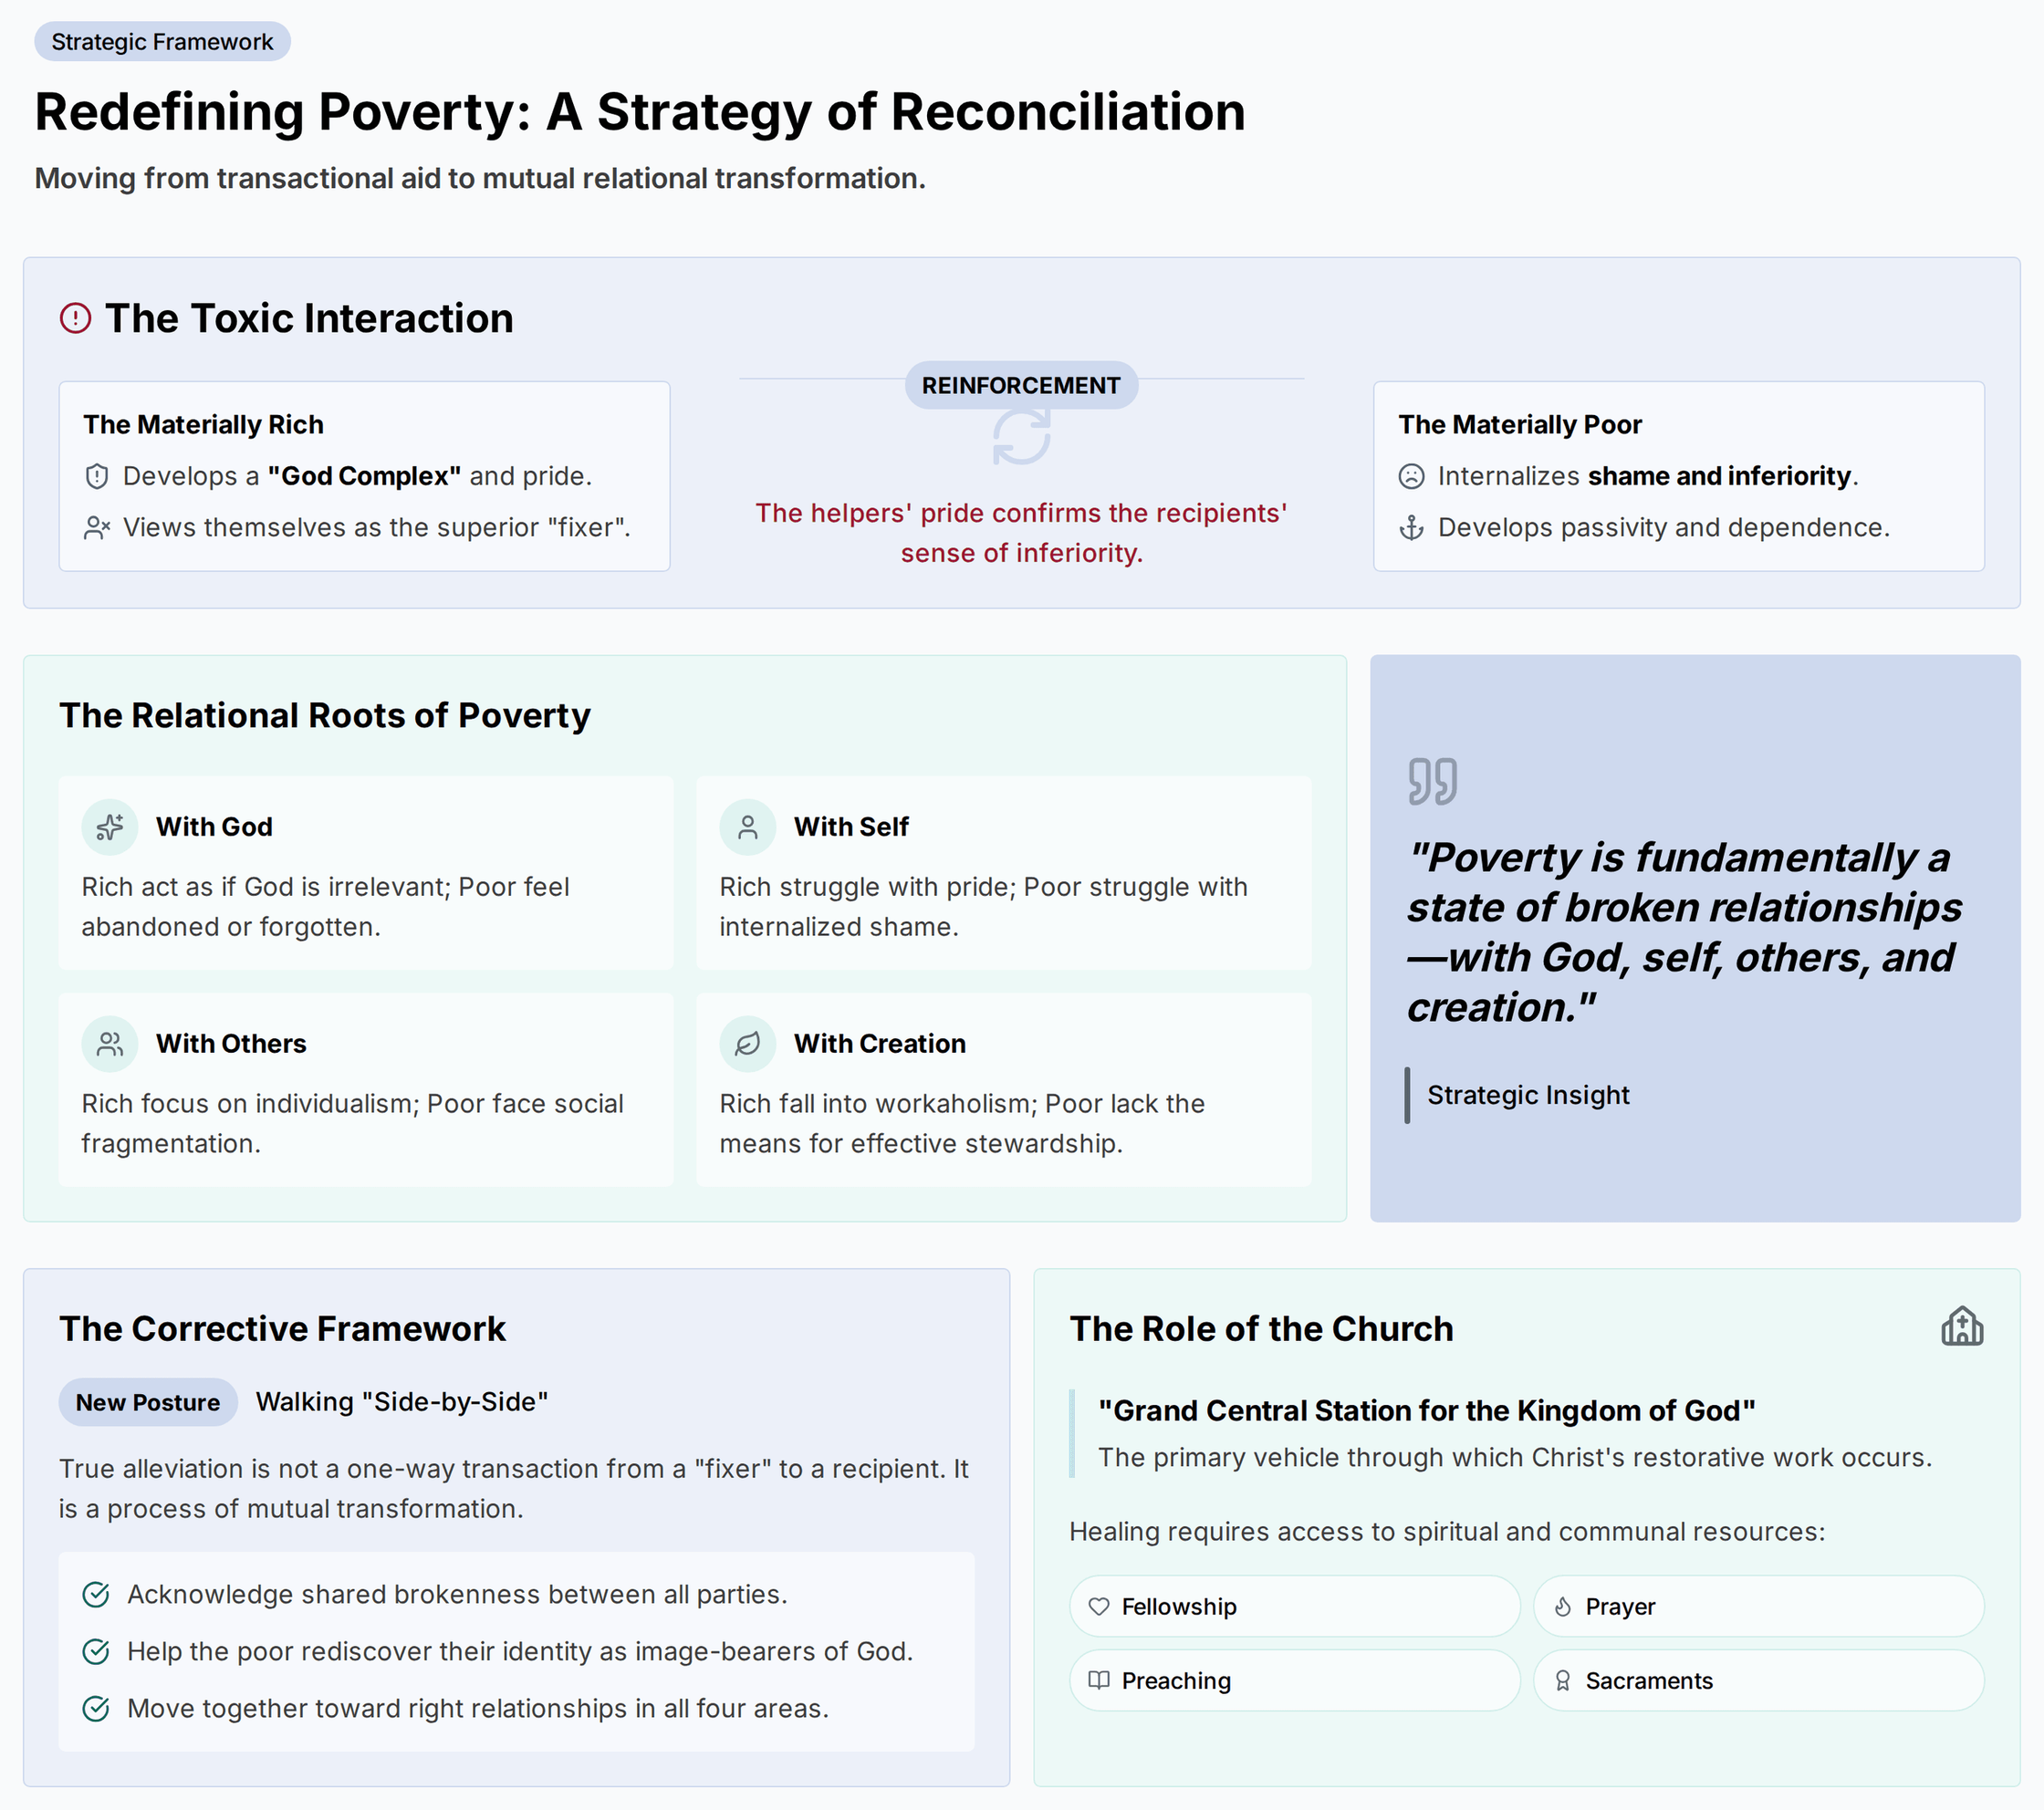

Core Synopsis
Poverty is fundamentally a state of broken relationships—with God, self, others, and creation—and is not limited to the materially poor. The speakers diagnose a critical flaw in traditional poverty alleviation: the interaction between helpers (often the materially rich) and the helped (the materially poor) reinforces the very brokenness it seeks to fix. The materially rich suffer from a “god complex,” workaholism, and self-centeredness, while the materially poor suffer from shame, inferiority, and conditioned hopelessness. When these two groups interact, the helpers’ pride confirms the recipients’ sense of inferiority, creating passivity and dependence. We must reframe our entire approach. True poverty alleviation is not a one-way transaction from a superior “fixer” to a passive recipient; it is a process of mutual transformation where both the materially rich and poor walk side-by-side, recognizing their shared brokenness and allowing for reconciliation in all four core relationships.

Diagnostic: The Relational Root of Poverty

The Shared Diagnosis: Poverty as Broken Relationships
Poverty is not merely a lack of material resources; it is a complex of four broken relationships that affect everyone, rich and poor alike, though the symptoms manifest differently.
- Relationship with God: The materially poor may feel abandoned, while the materially rich act as though God is irrelevant or nonexistent.
- Relationship with Self: The poor often internalize a sense of shame and inferiority. The rich often exhibit a “god complex,” pride, and a sense of superiority.
- Relationship with Others: The poor may experience social fragmentation, while the rich are marked by individualism and self-centeredness, often not even knowing their neighbors.
- Relationship with Creation: The poor may lack the means to be effective stewards, while the rich’s stewardship is corrupted into a drive for over-consumption and a workaholism rewarded by society.

The Toxic Interaction: Why Traditional “Help” Fails
The core problem is the dynamic created when these two forms of brokenness meet.
- The Mechanism: When individuals with a sense of superiority (the “helpers”) engage with those feeling shame and inferiority (the “helped”), the interaction is inherently damaging. The helpers’ actions, tone, and approach—even when well-intentioned—often confirm the poor’s belief that they are helpless and inferior.
- The Result (Negative Feedback Loop):
  - The poor become more passive and dependent, believing they need a savior.
  - The helpers’ pride is reinforced, confirming their own biases (“I knew they were lazy,” “I knew they couldn’t do it themselves”).
  - This cycle deepens the brokenness on both sides, preventing true, lasting change. It addresses external circumstances while poisoning the internal sense of dignity and agency.

The Strategic Mandate: A Pivot to Reconciliation

The Corrective Framework
The solution is to shift the goal from “fixing” the poor to reconciling broken relationships for all parties involved.
- The New Definition: Poverty alleviation is a process in which both the materially poor and the non-poor move closer to right relationship with God, self, others, and creation.
- The New Posture: It is not about a superior party descending to help an inferior one. It is about walking “side by side” and “hand in hand,” acknowledging shared brokenness and the need for mutual transformation. The primary work is to help the poor rediscover their identity as image-bearers of God, called to be stewards of their own resources.

The Role of The Church
The local church is identified as the central, yet often missing, vehicle for this reconciled approach. It is positioned as “Grand Central Station for the Kingdom of God,” the primary body through which Christ’s restorative work occurs.
- The Call to Action: The poor need access to the spiritual resources of the church—fellowship, prayer, preaching, the Lord’s Supper—as these are foundational to healing broken spiritual relationships. Churches must become accessible and integrated into the work of poverty alleviation in their communities.

